Sensory pack
We recognise that many people with Neurodiverse conditions, can experience overstimulation or under stimulation by their environment referred to as hypersensitivity or hyposensitivity. To support a more inclusive environment we have available this sensory pack.
Please don’t forget to hand back at the end of your visit.

Item Name | Description
Ear defenders / headphones | Ear Defenders can be helpful for individuals who are sensitive to noise and certain sounds.  Good for:  - Reducing sounds around  - Provides a safer space for the wearer | 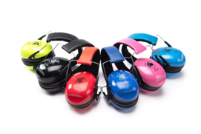
Resistance band | Resistance Bands are stretchy, wide rubber bands that provide proprioceptive input.  Good for:  - Sensory regulation  - Helps calm and ground the nervous system  - Increases body awareness  - Supports emotional regulation
Fidget Items | Fidget toys can provide a constructive outlet for excess energy. Included are 2 different toys, a Sensory Stretchy hand toy and a Pop fidget toy.  Good for:  - Sensory regulation  - Helps calm and ground the nervous system  - Supports emotional regulation  - Reducing anxiety
Stress ball | Tactile ball to allow the user to experience a deep and calming pressure to the sensory system.  Good for:  - Reducing anxiety  - Applies deep pressure

